

Tata Capital Ltd., the financial services unit of India’s Tata Group, is planning for one of the most significant initial public offerings (IPOs) of India in 2025, raising approximately ₹17,000–18,000 crore in primary and secondary offerings.

"This is not just a regulatory listing, but a purposeful entry into the capital markets for a performance-led, systemically important lender," According to a Mumbai-based investment banker who advised on the transaction.

The listing is expected in Q3 FY2025 and follows Reserve Bank of India (RBI) regulations that mandate an “upper-layer” non-banking financial companies (NBFCs) to become publicly listed by September 2025.

Structure of offer and timings

➢ A fresh issuance of about 230 million shares to raise equity capital amounting to approximately ₹7,000–7,500 crore, and
➢ An Offer for Sale of an equal number of shares from Tata Sons.
➢ The IPO will be managed by a consortium of distinguished global and domestic investment banks, including Kotak Mahindra Capital, Citi, Axis Capital, ICICI Securities, HDFC Bank, J.P. Morgan, HSBC, and SBI Capital.

According to individuals involved with the deal, the IPO is expected to be launched between July and September 2025. The predicted price band is around ₹325–₹365, but shares in the unlisted market are trading over ₹1,000, indicating healthy pre-market interest.

A Hybrid Lending Powerhouse

Founded in 2007, Tata Capital is a diversified financial service operator providing retail, SME, and infrastructure loans, as well as wealth and investment advisory. Operating in over 900 cities, Tata Capital has developed to manage a broad portfolio in personal finance, housing, vehicle financing, and corporate credit.

Key financial metrics (FY2024-25):
Loan Book: ₹1.57 lakh crore
Revenue: ₹18,178 crore
Profit After Tax: ₹3,327 crore
Net Interest Margins (NIM): 6.5–7.1%
Gross NPA / Net NPA: 1.5% / 0.38%
Return on Equity: ~16–18%
Capital Adequacy Ratio: 18.6% (Tier I: 15.9%)

Across credit cycles, Tata Capital has consistently maintained strong earnings, reflecting operational efficiency and rational risk management.

Regulatory Knowing and Time Management

The RBI’s scale-based regulation (SBR) framework mandates that NBFCs in the upper-layer category will need to list for transparency and market discipline. Tata Capital is one of only 16 NBFCs in this category and amongst the early NBFCs to satisfy the listing requirement ahead of the September 2025 deadline.

e The following is also in line with Tata Group’s broader aspirations to start unlocking value in its private subsidiaries, as demonstrated by the Tata Technologies IPO in 2023 and Tata Play's continued path towards listing.

Investment Thesis: A Structural Long-Term Play

Strengths-
➢ Brand & Governance: Backed by Tata Group’s legacy and governance standards
➢ Diversification: With a broad lending book, the risk emanating from one segment is reduced
➢ Digital Adoption: Committed to building digital lending platforms and partnerships in fintech to scale volumes
➢ Growth Tailwinds: robust upward momentum on retail/ MSME loan demand, demographics, and financial inclusion

Risks-
➢ Valuation Premium: Pricing at projected multiples (P/E ~27–30x) needs to be backed by growth and margin stability.
➢ Credit Costs: Credit provisions to ₹581 crore; FY24 was $677 crore—let's keep an eye on it as there are bigger headwinds in the macro environment.
➢ Sectoral Cyclicality: NBFCs remain vulnerable to cycles in liquidity, funding costs, and regulatory interventions.

Market Outlook and Institutional Demand
Analysts are anticipating significant participation from institutional and anchor investors, especially from global funds that want access to India’s credit cycle while avoiding the baggage of public sector ownership and risk.

“It’s a view on the formal credit deepening in India, but in a Tata-like risk profile,” said a senior analyst at a foreign institutional brokerage. “The size is rare, the pedigree is strong, and the timing in the market is appropriate.”

Retail demand may depend on the final price band and how it compares to the unlisted premium currently being paid. If the IPO is aggressively priced, the short-term listing gains could be pulled in, although it may not deter long-term allocations.

Conclusion

The Tata Capital IPO is a seminal event for both the Tata Group and India’s non-banking financial services market. Given that regulatory reforms are tackling the sector and investor appetite across the more diverse non-banking financials grows, the offering presents a unique case for investing in a diversified, technology-enabled lender with systemic importance and strategic intent.

Even if valuation sensitivity and sector-specific risks exist, Tata Capital's fundamentals, scale, and governance profile are undoubtedly positioned to be a potential core holding for long-term investors wishing to gain exposure to the Indian credit growth story.
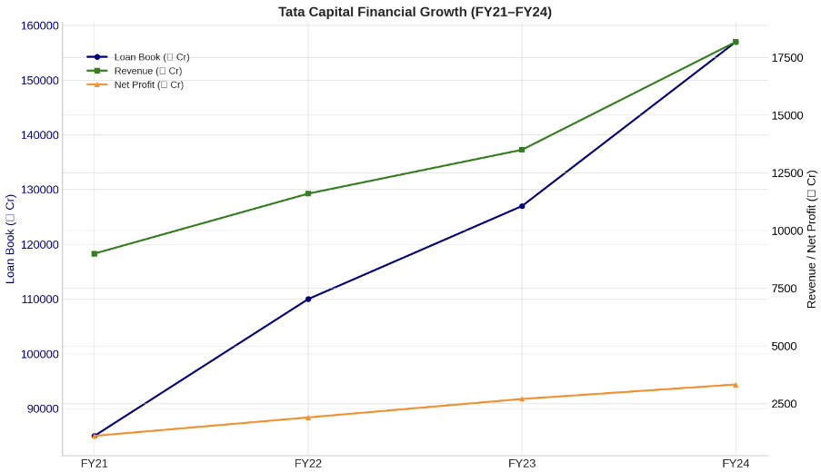

Disclaimer: This article is for informational purposes only.

Authored By: Deepika Bhattad

